**VISVESVARAYA TECHNOLOGICAL UNIVERSITY**

**“JnanaSangama”, Belgaum -590014, Karnataka.**



**PROJECT WORK-1 REPORT**

**on**

**SinFo**

***Submitted by***

**MOHAMMED ABDUL HAMID (1BM19CS202)**

**RAHUL SURESH (1BM19204)**

**ANIRUDHA ACHARYA (1BM19CS193)**

***Under the Guidance of***

**Prof. Bhoomika AP**

**Assistant Professor, BMSCE**

|  |  |
| --- | --- |
|  |  |

***in partial fulfillment for the award of the degree of***

**BACHELOR OF ENGINEERING**

***in***

**COMPUTER SCIENCE AND ENGINEERING**



**B.M.S. COLLEGE OF ENGINEERING**

**(Autonomous Institution under VTU)**

**BENGALURU-560019**

**Sep-2020 to Jan-2021**

**B. M. S. College of Engineering,**

**Bull Temple Road, Bangalore 560019**

(Affiliated To Visvesvaraya Technological University, Belgaum)

**Department of Computer Science and Engineering**



**CERTIFICATE**

This is to certify that the project work entitled “**SinFo**” carried out by **MOHAMMED ABDUL HAMID (1BM19CS202), RAHUL SURESH(1BM19CS204) & ANIRUDHA**

**ACHARYA(1BM19CS193)** who are bonafide students of **B. M. S. College of Engineering.** It is in partial fulfillment for the award of **Bachelor of Engineering in Computer Science and Engineering** of the Visveswaraiah Technological University, Belgaum during the year 2020-2021. The project report has been approved as it satisfies the academic requirements in respect of **Project Work-1 (19CS3PWPW1)**work prescribed for the said degree.

Signature of the Guide                 Signature of the HOD

Bhoomika AP Dr. Umadevi V

Assistant Professor Associate Prof.& Head, Dept. of CSE

BMSCE, Bengaluru BMSCE, Bengaluru

External Viva

Name of the Examiner                                                                                       Signature with date

1._____________________________ ________________________

2. _____________________________ _________________________

**B.M.S. College of EngineerinG**

**DEPARTMENT OF COMPUTER SCIENCE AND ENGINEERING**



***DECALARATION***

We, MOHAMMED ABDUL HAMID (1BM19CS202), ANIRUDHA ACHARYA (1BM19CS193), RAHUL SURESH (1BM19CS204), students of 3rd Semester, B.E, Department of Computer Science and Engineering,B. M. S. College of Engineering, Bangalore, hereby declare that, this Project Work-1entitled "Project Title" has been carried out by us under the guidance of,Assistant Professor Bhoomika AP, Department of CSE, B. M. S. College of Engineering,Bangalore during the academic semester Sep-2020-Jan-2021.

We also declare that to the best of our knowledge and belief, the development reported here is not from part of any other report by any other students.

Signature

MOHAMMED ABDUL HAMID (1BM19CS202)

RAHUL SURESH (1BM19CS204)

ANIRUDHA ACHARYA (1BM19CS193)

1. Introduction

Sinfo, short for “**S**tartups-**info**rmation”, is a website where New Startups can host about themselves of what they do and what they are looking for. As we are entering into new decade and as we progress into new world of Technology, We the new Generation has abundant resources. There has been increasing number of new Startups and to overcome that we designed a webpage where Startups and business can be hosted. Interested individuals or groups can see through different startups. This will provide Advertising, Power, Investments, Marketing and Partnership.

This online system supports following users

a. Individual

b. Startup/Organization

**Common Functionalities-**

1. **Logging in as an Individual or Company**
2. **Exploring through different companies**

**Can explore different startups posted, and know more about them.**

2. Design Layouts: Screen Shots of Webpages

2.1: Home Webpage

Home webpage consist of our Introduction followed by the Services we provide.

Fig 1.a Homepage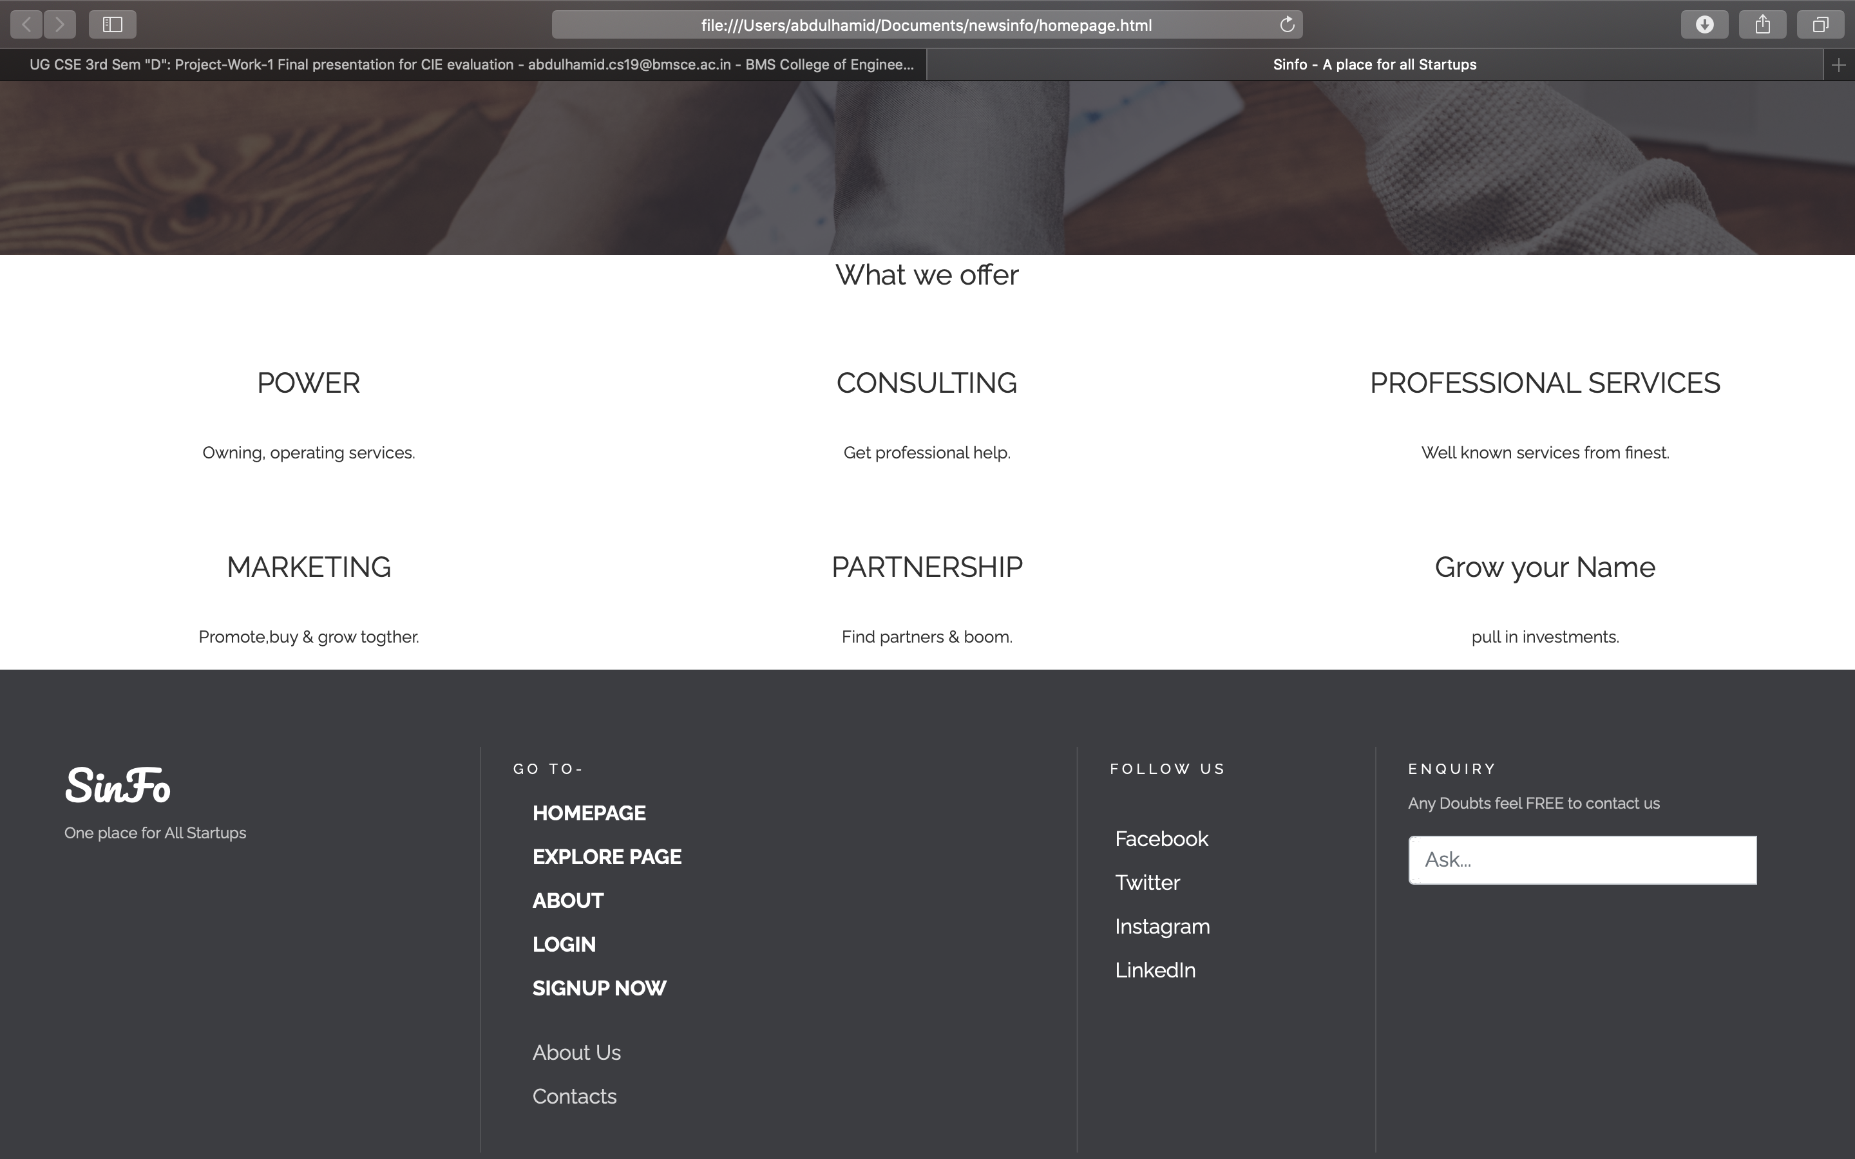

Fig 1.b Homepage

2.1: Explore Webpage

In Explore webpage, you’ll find the startups and new eye catching business that is will be hosted on Sinfo. You can click on “click here for more detail” if you are interested in the Startup posted.

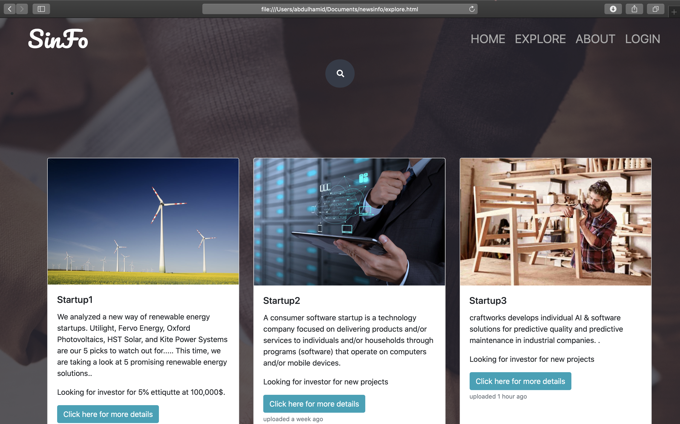

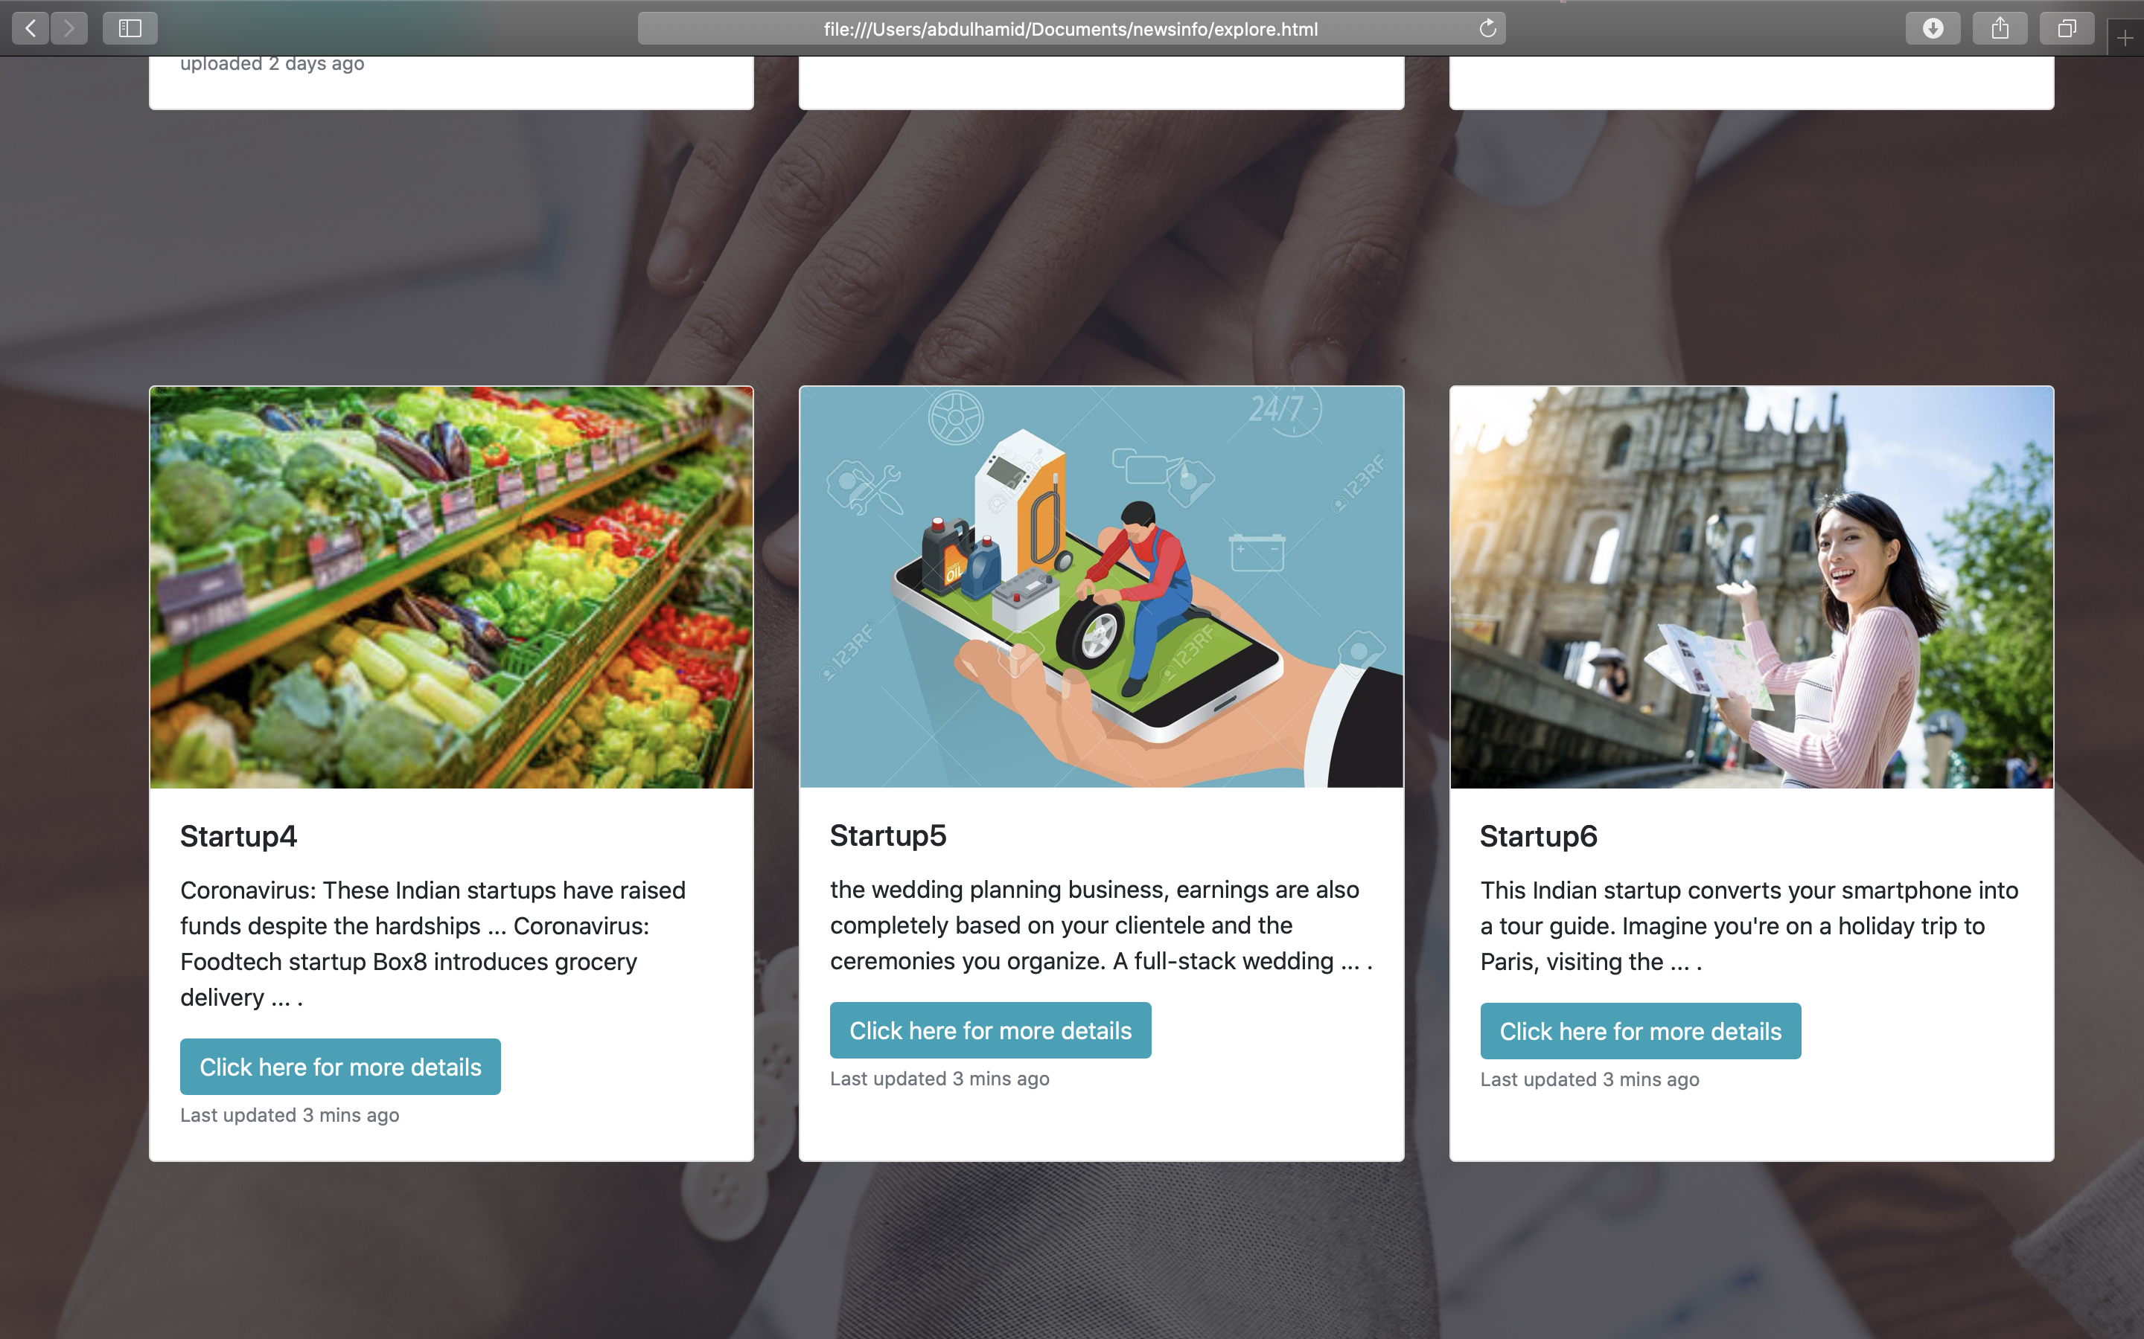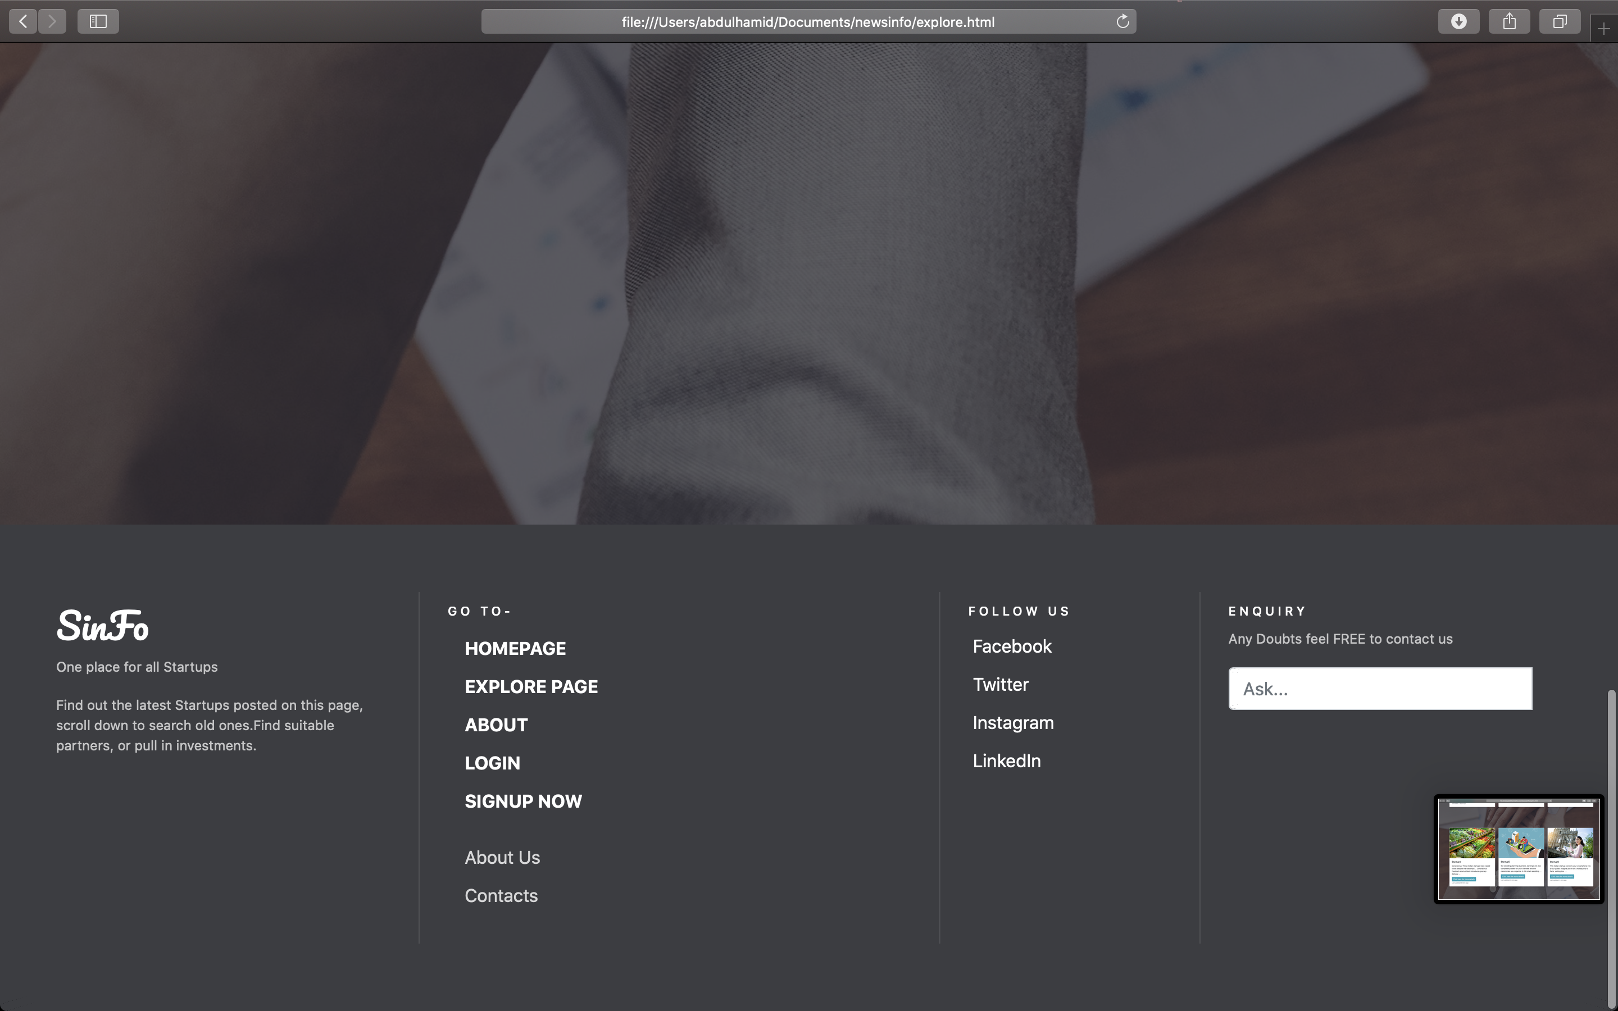

2.1:Sub-Explore Webpages

There are currently 6 startups posted on the website. Which is accessed through Explore webpage.

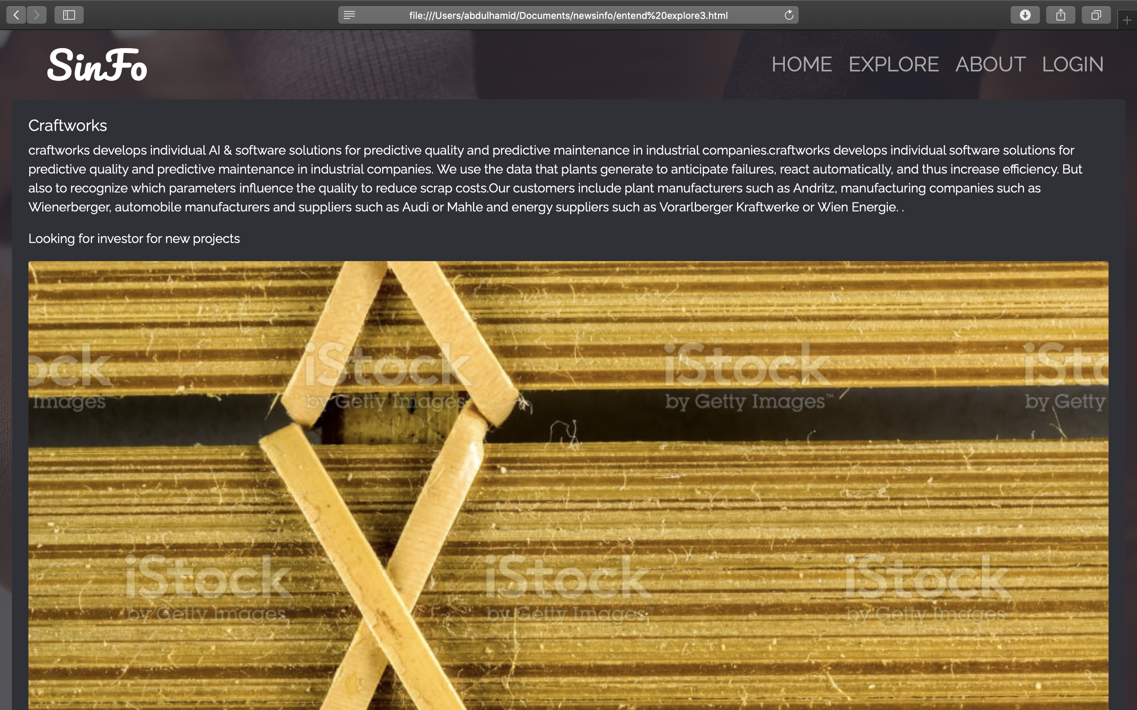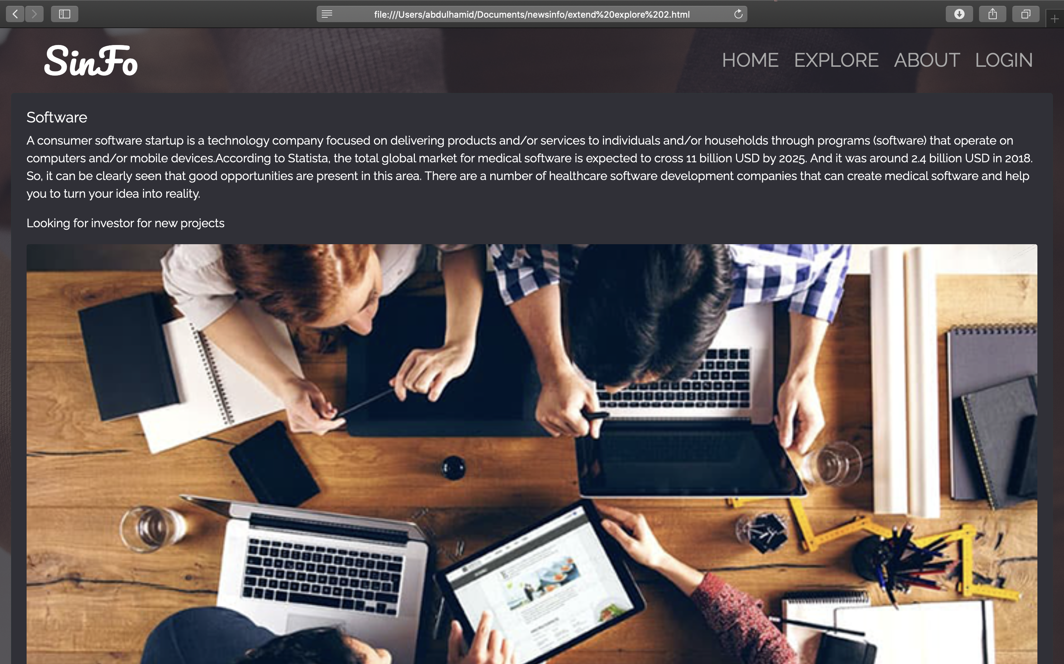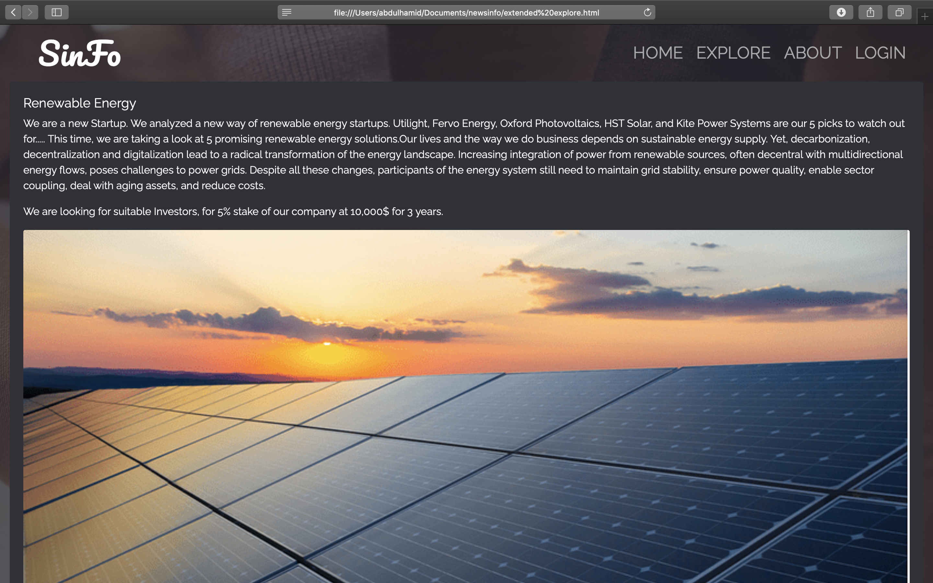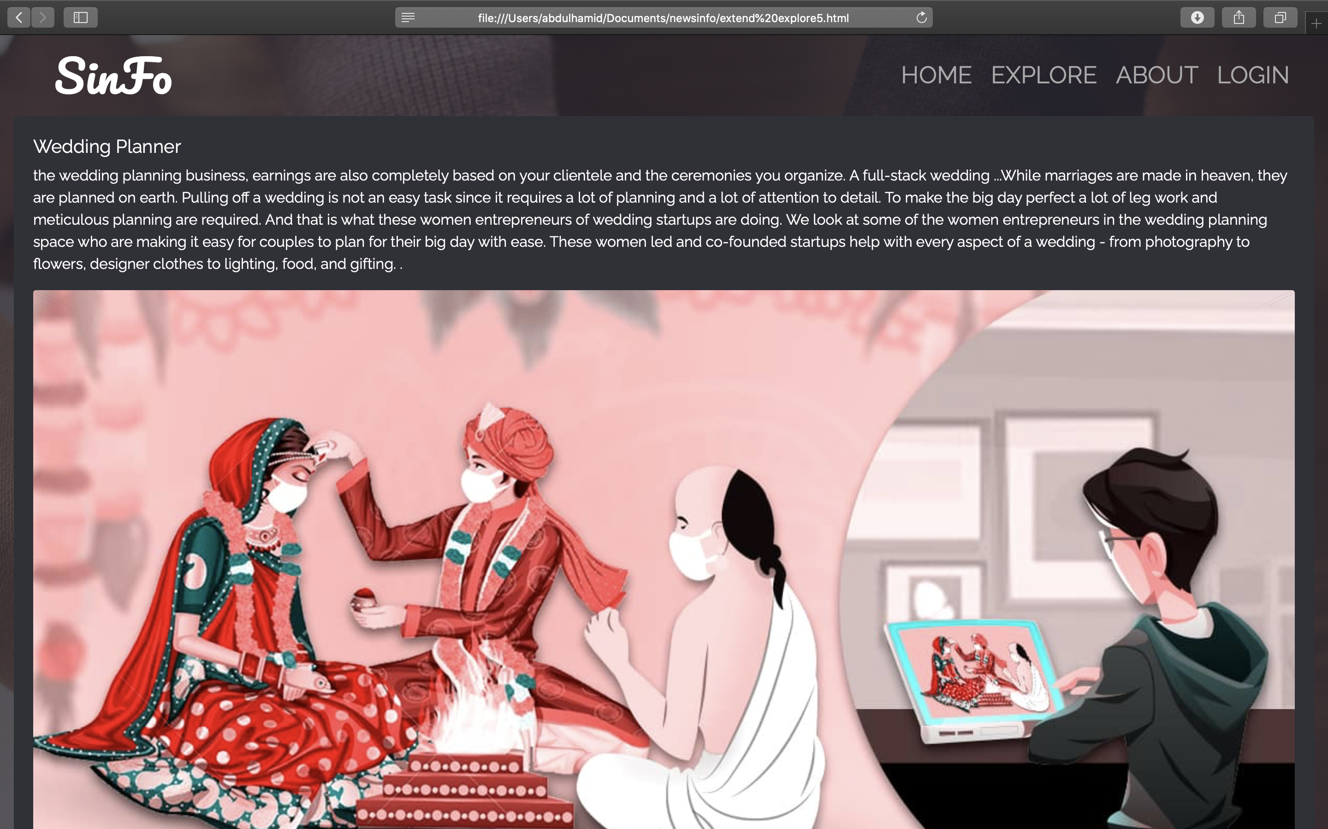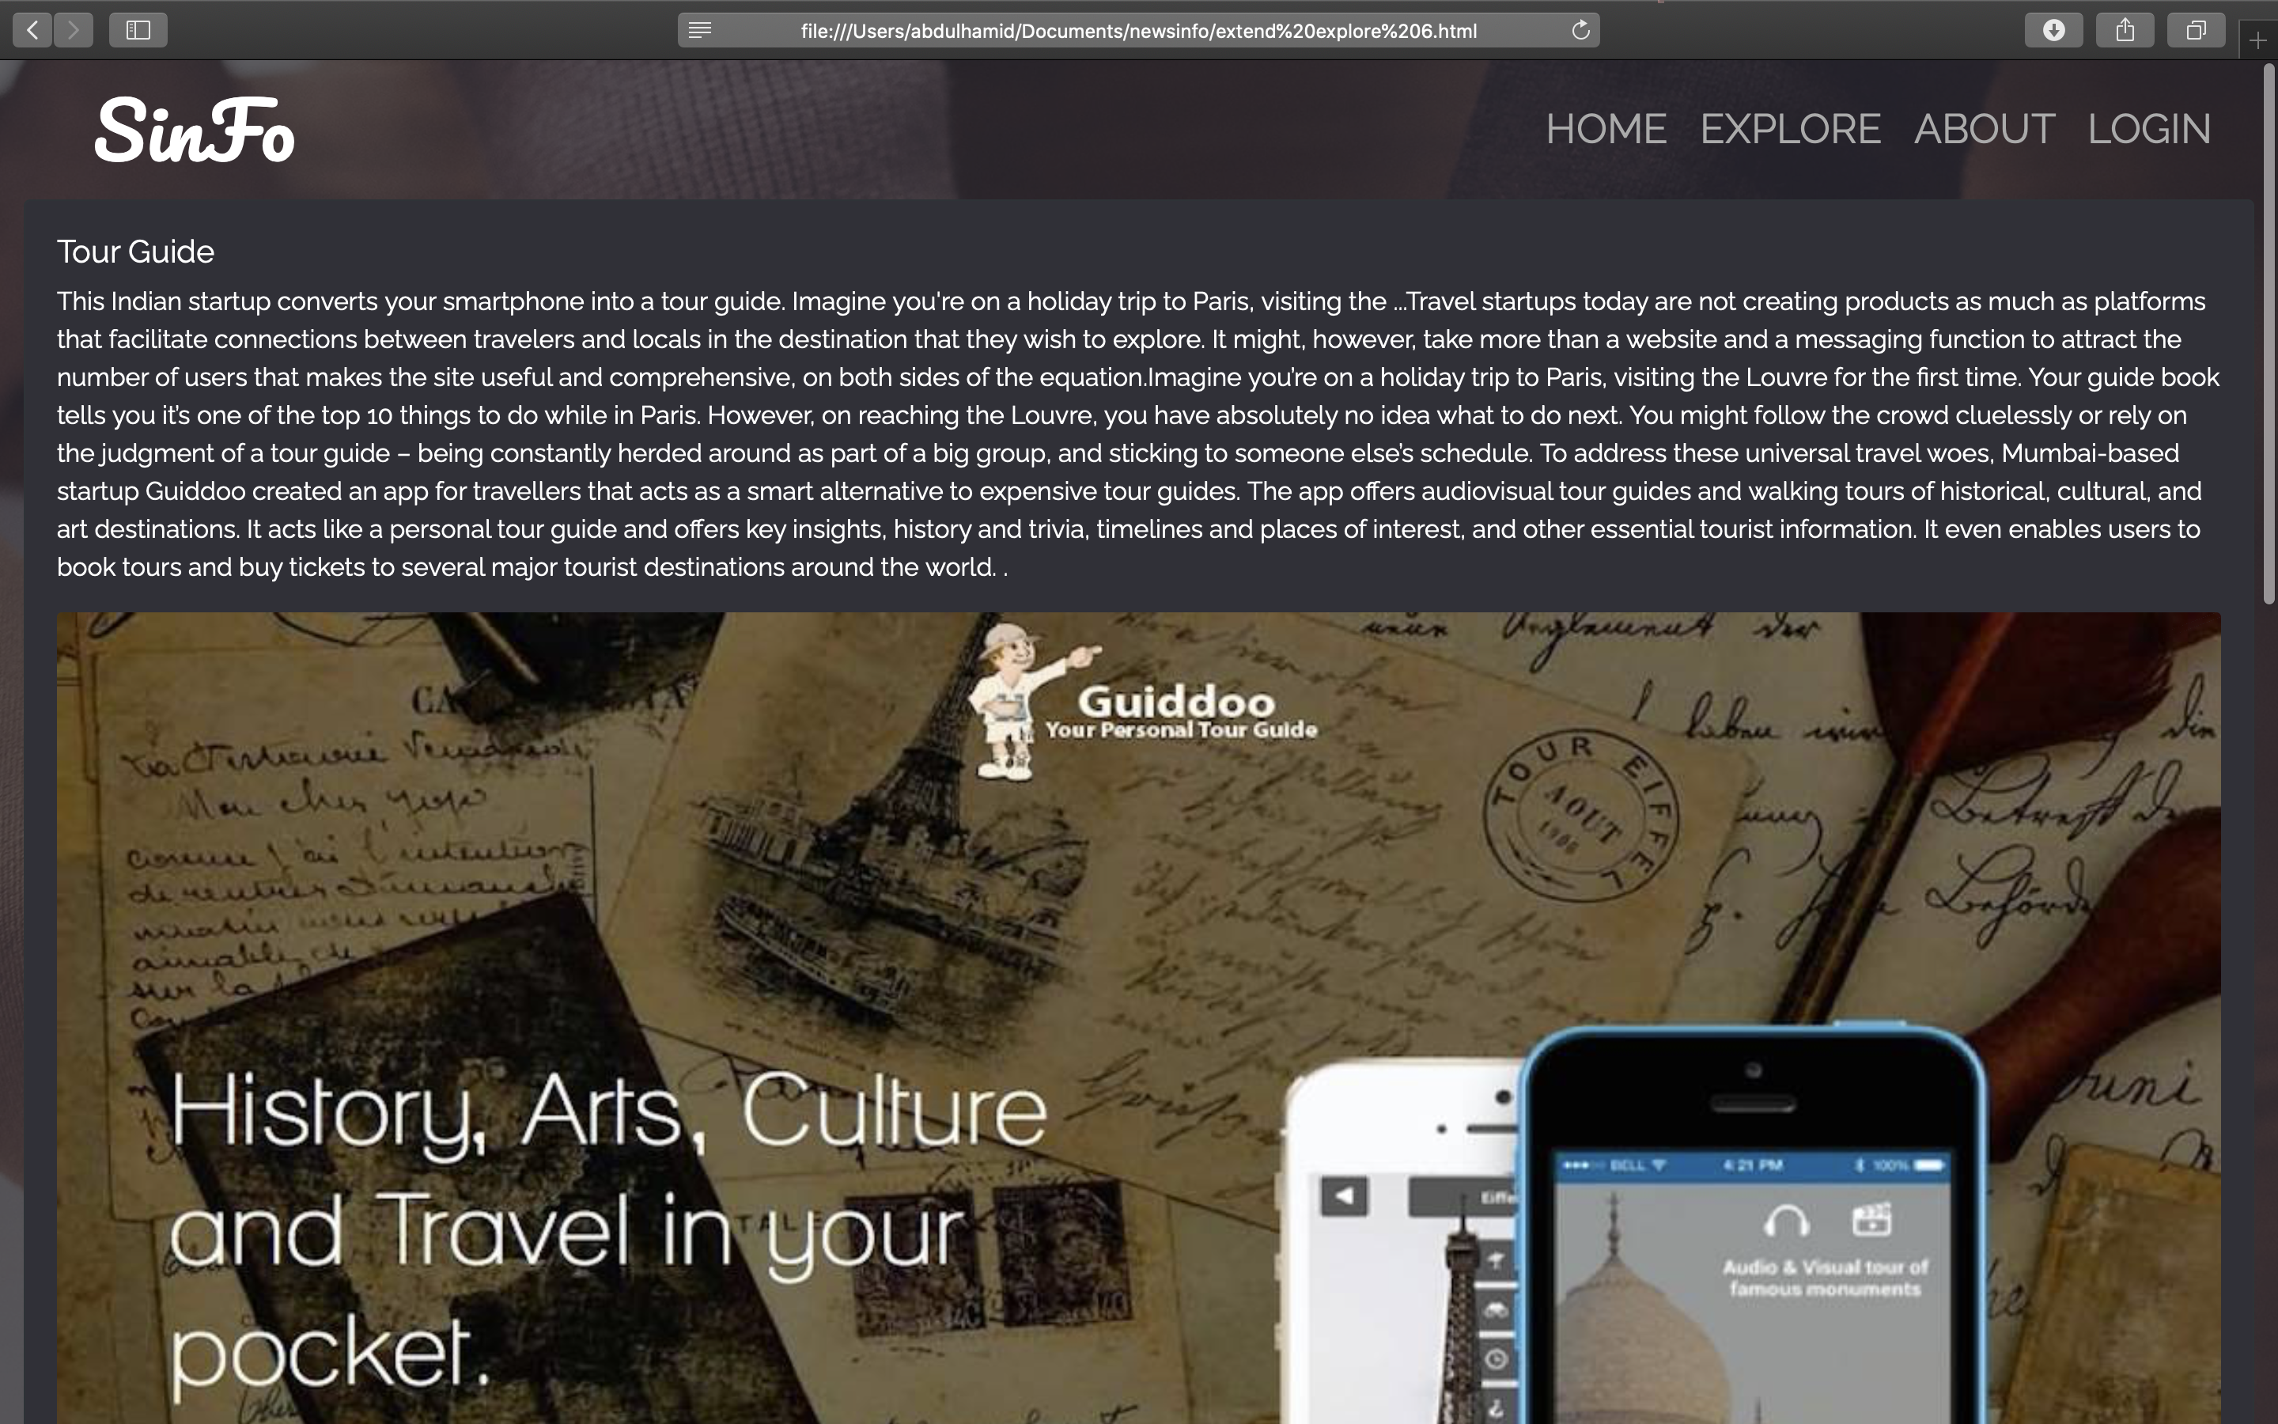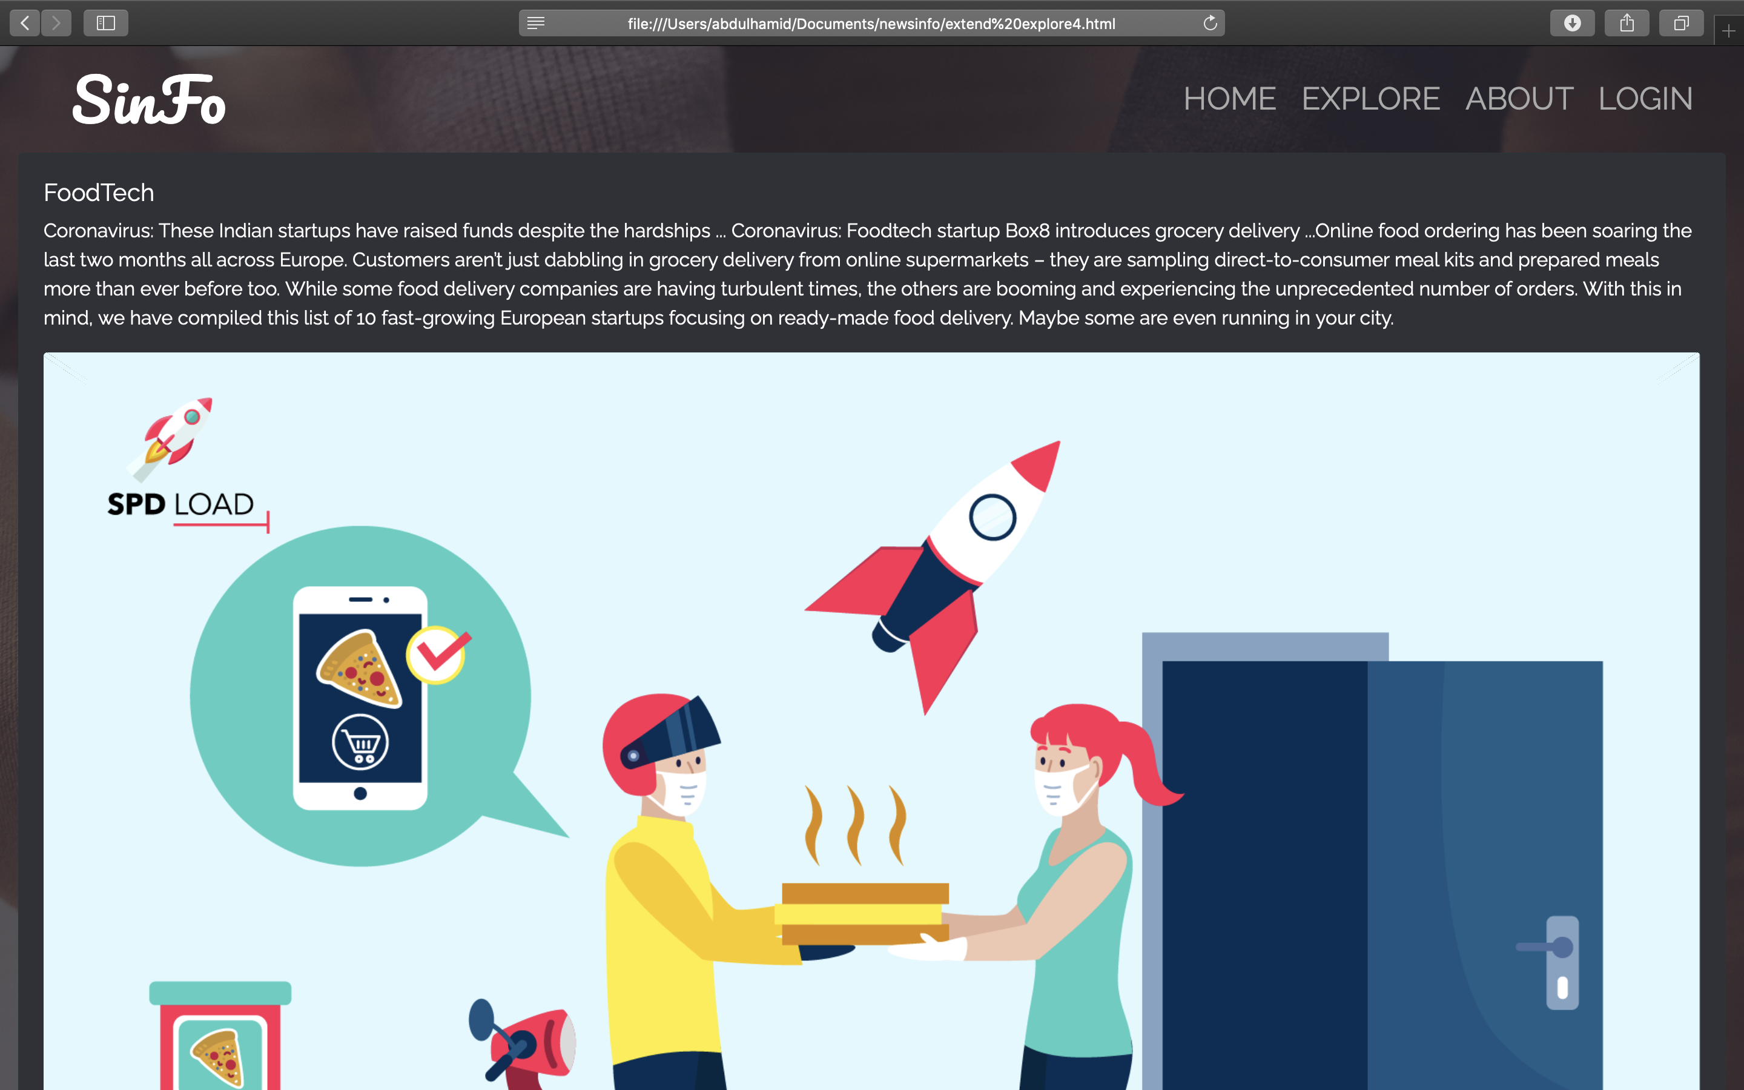

2.1:About Webpage

The About consist of 4 slides along with Startups in India.

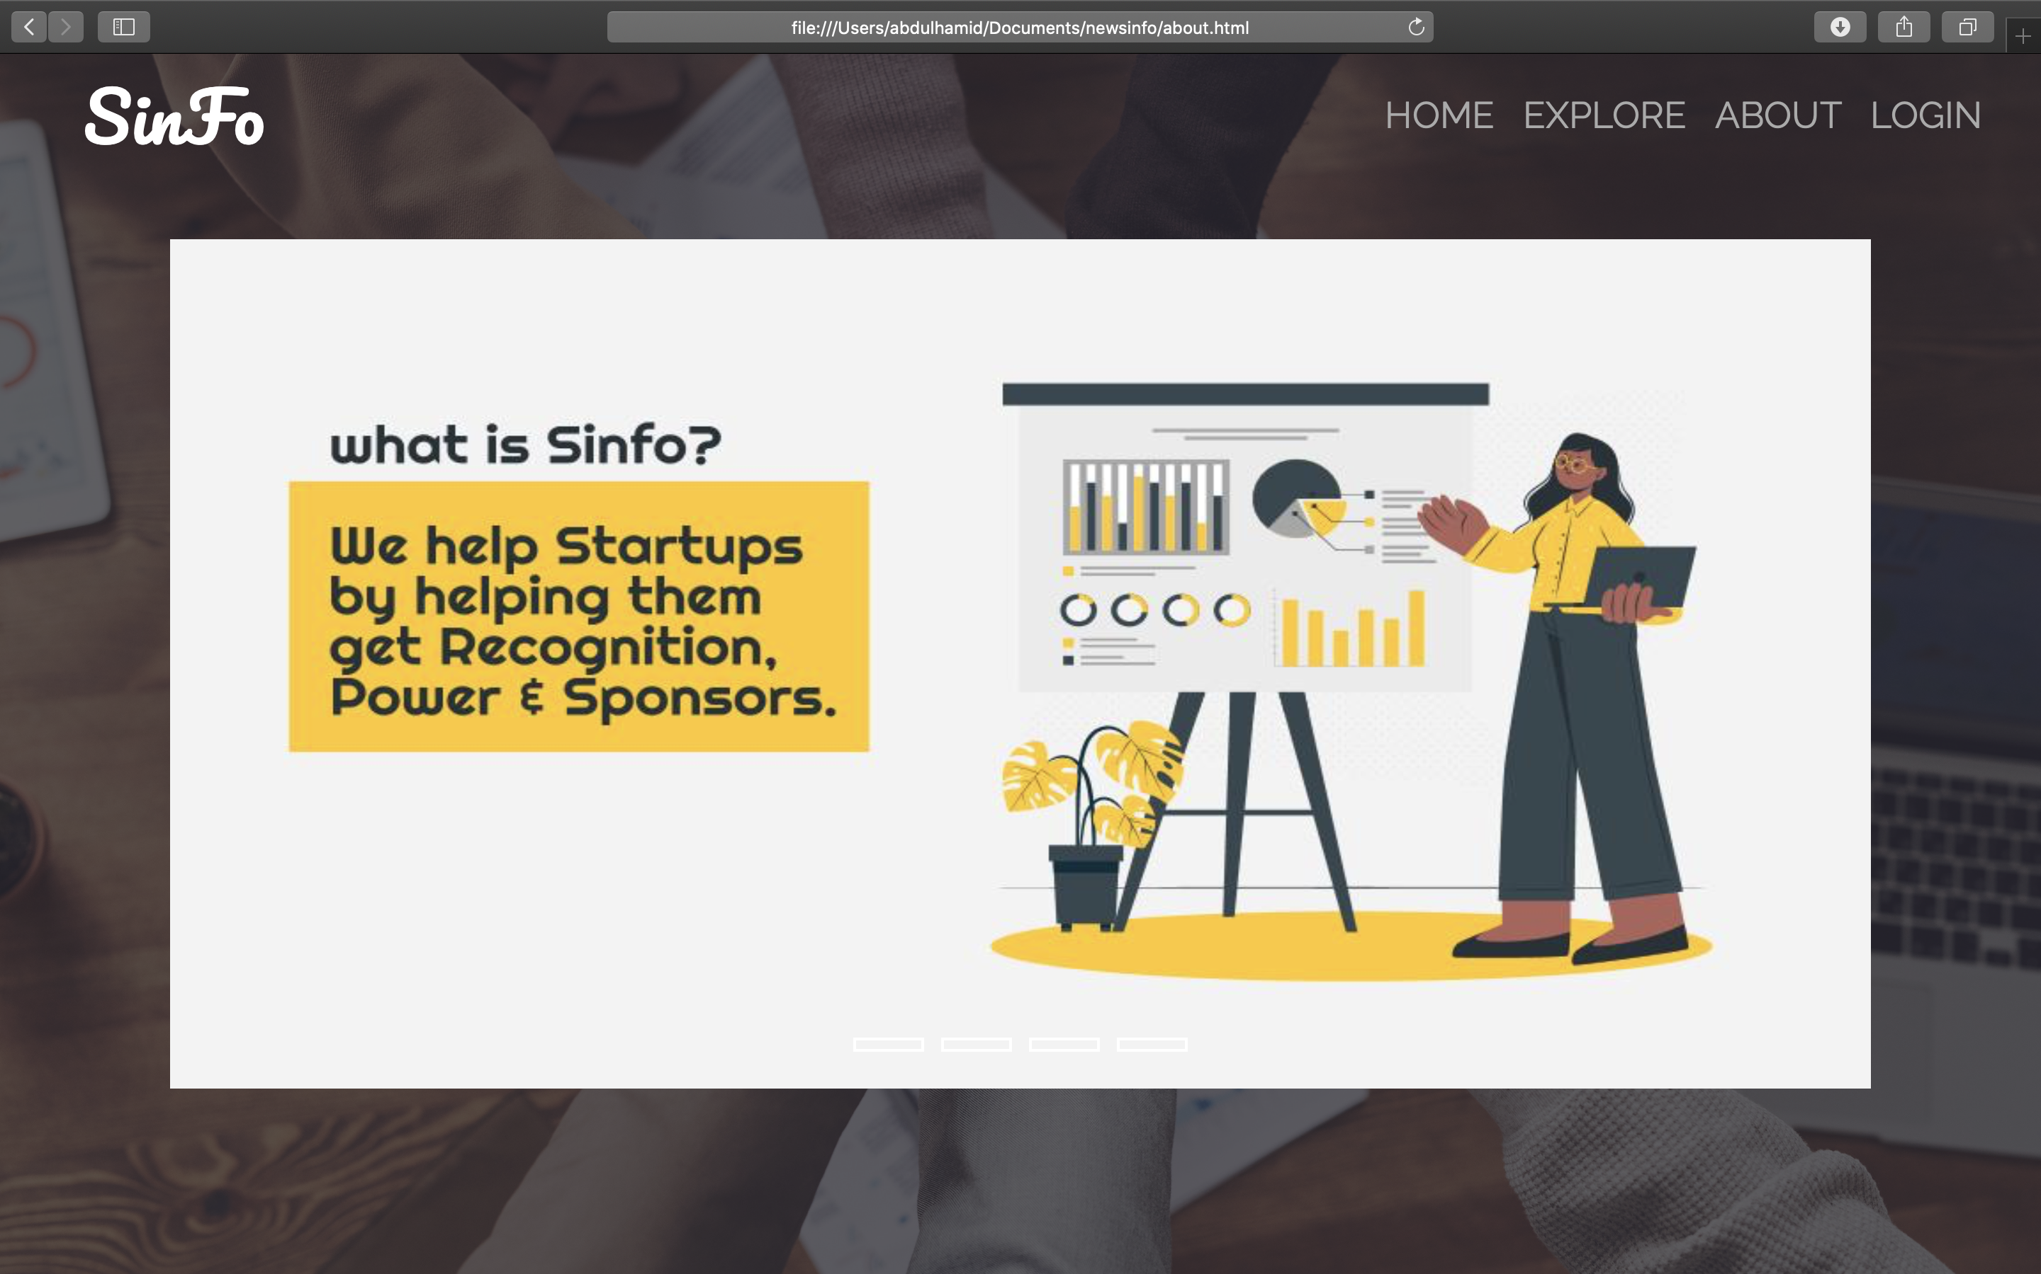

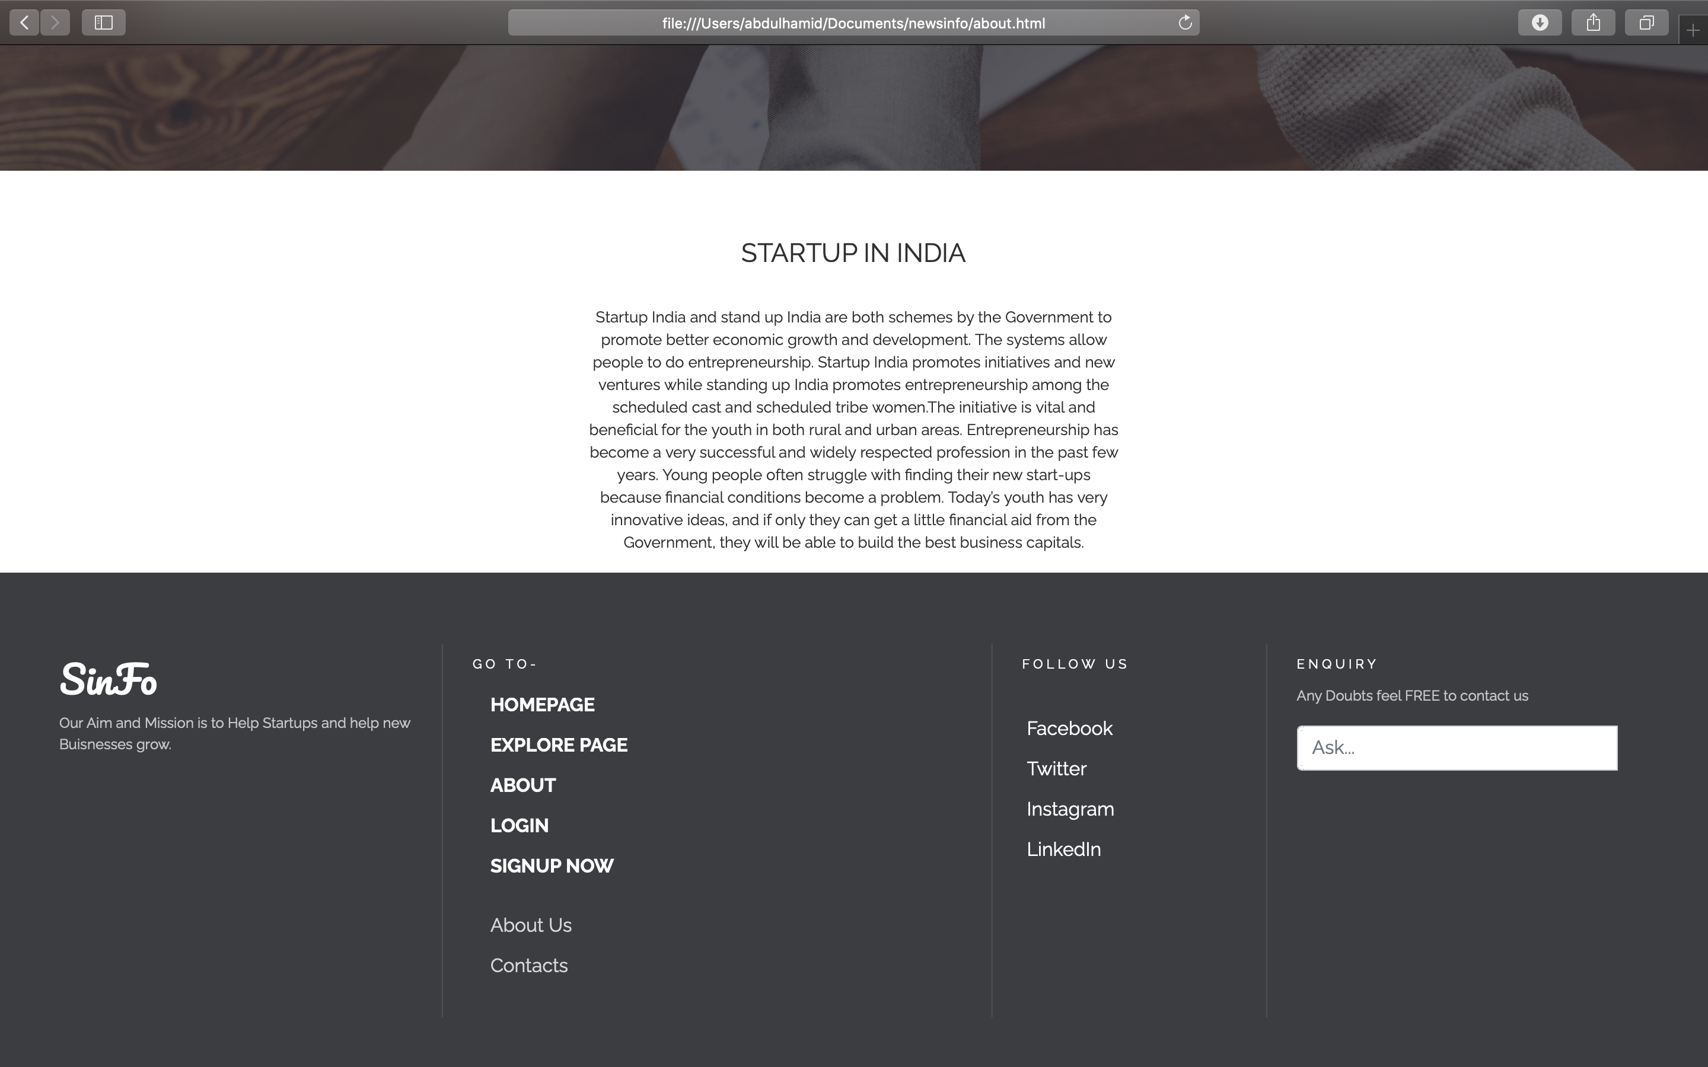

2.1:Login Webpage

Regular Sign-in page along

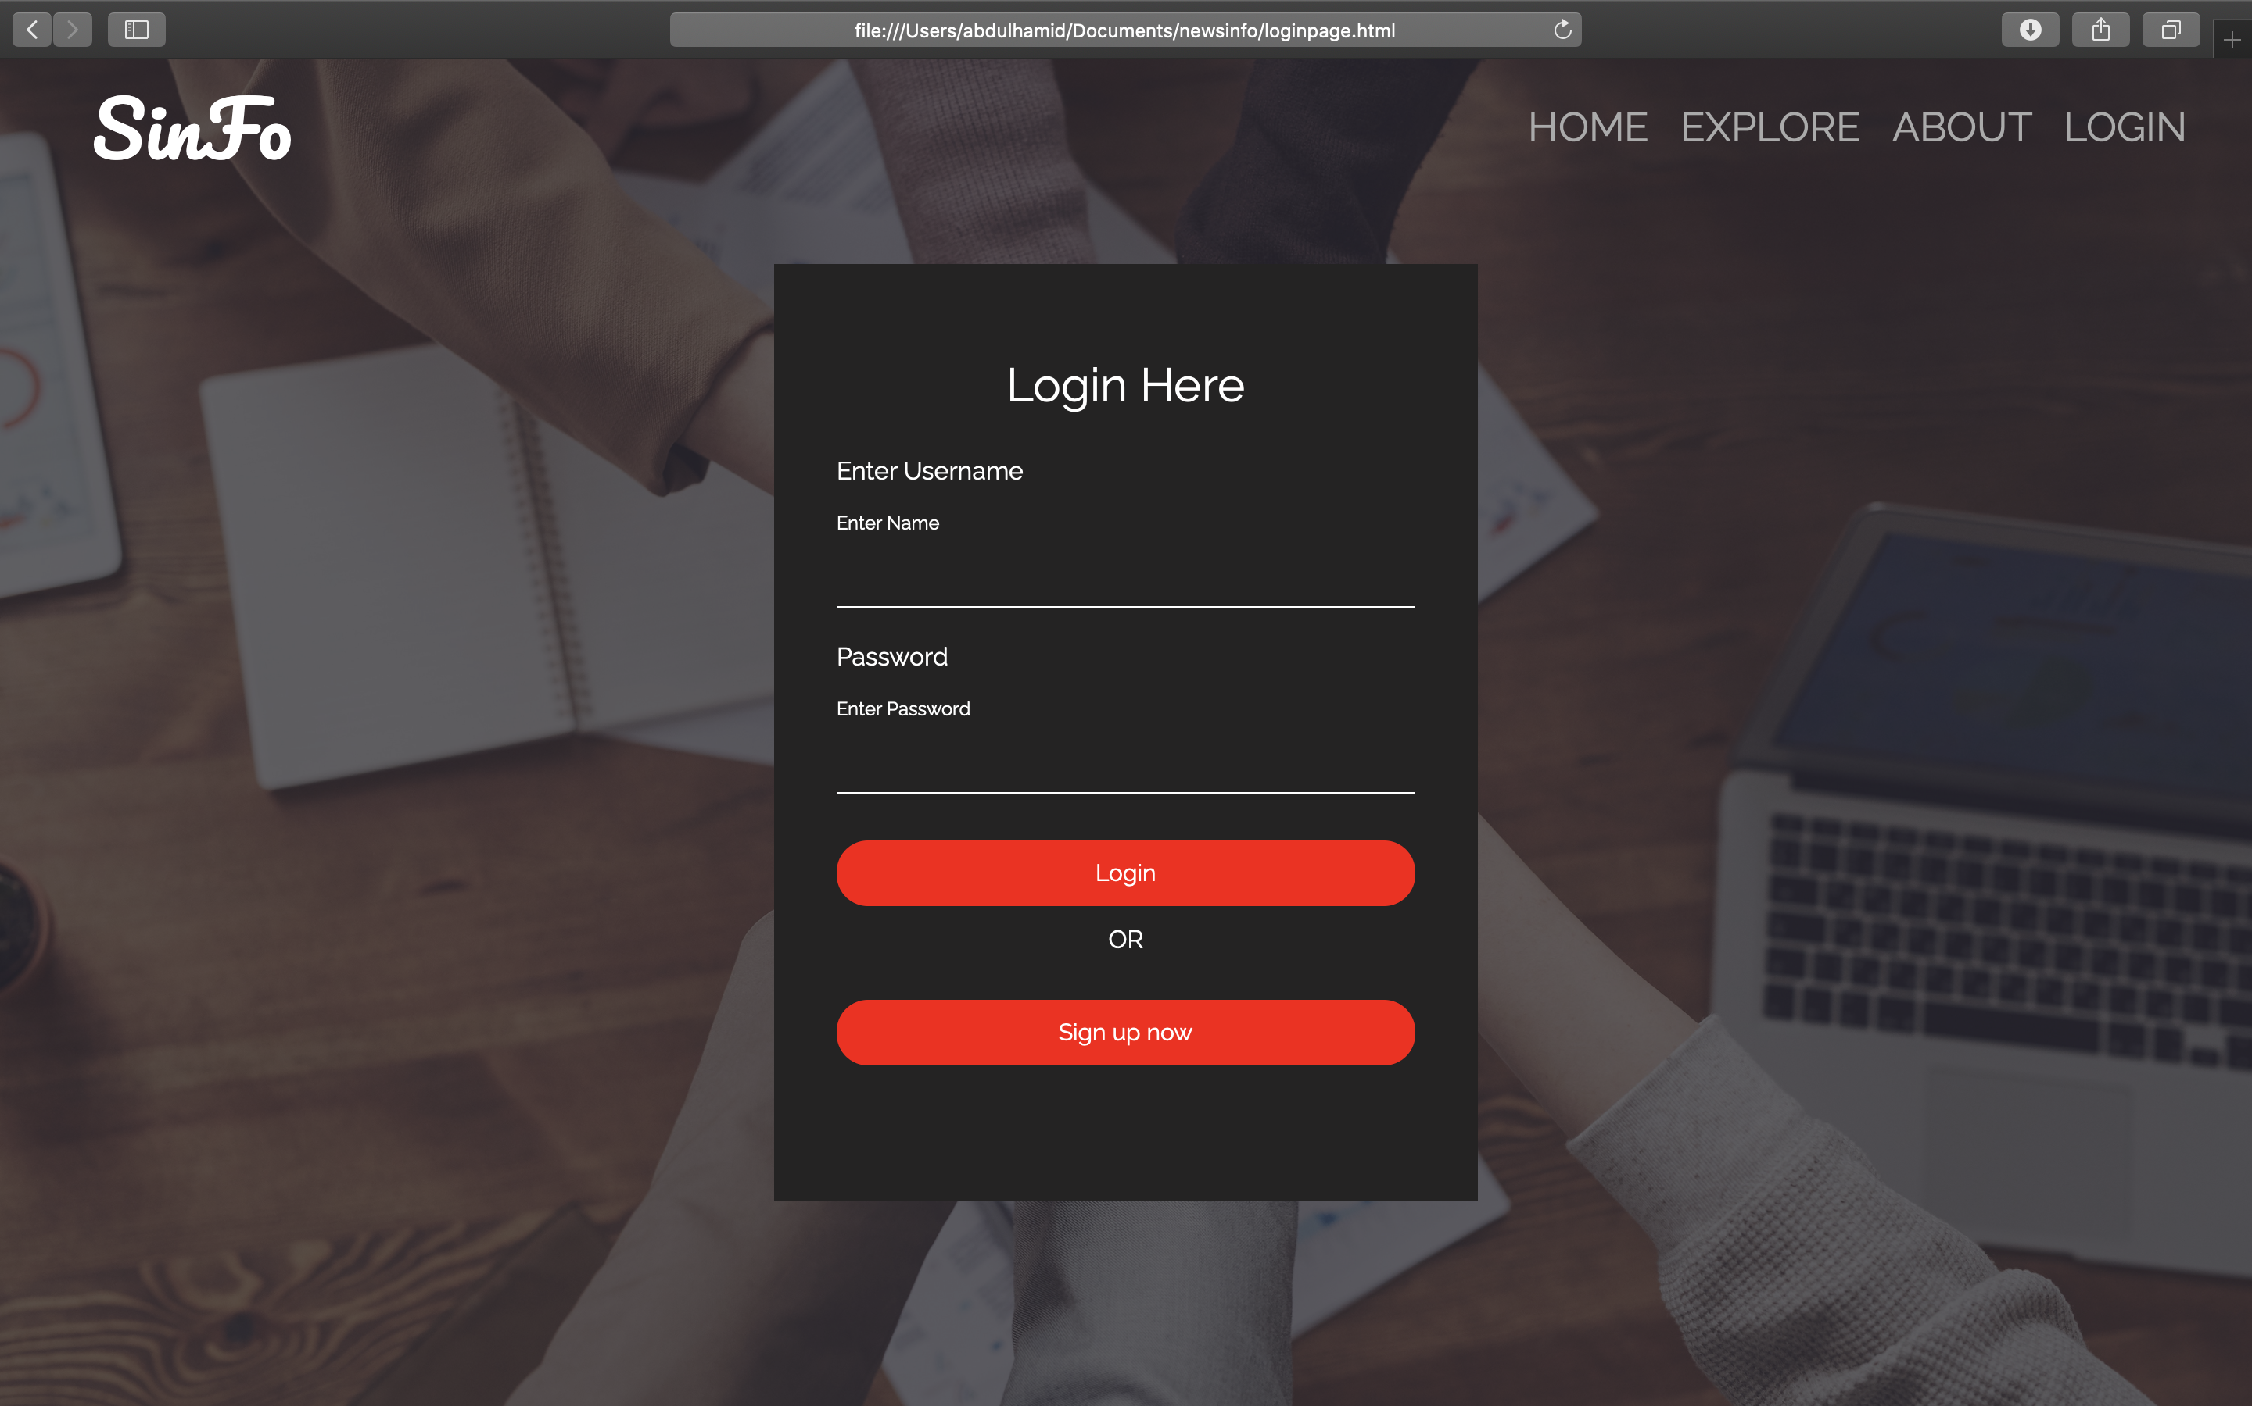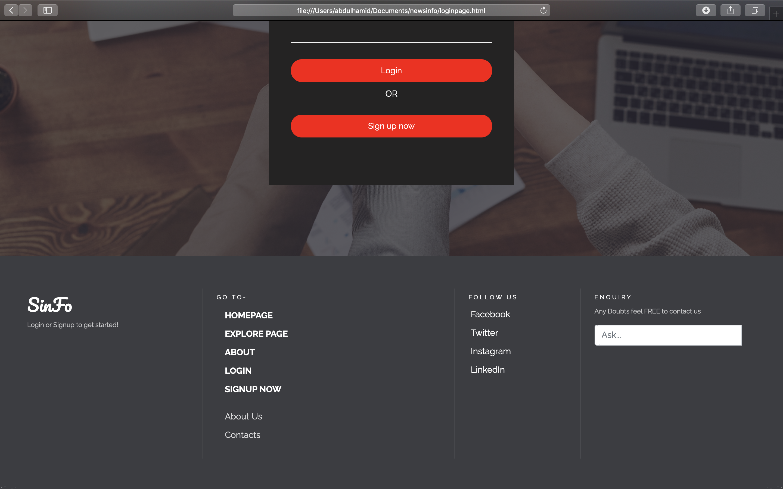

2.1:Signup Webpage

The Signup webpage consist of 2 option whether you want to signup as an Individual or as A Startup.

